ENCOMPASS

|  |  |
| --- | --- |
| Name | Student Number |
| JULIANNA VENTER | U20433752 |
| MORGAN BENTLEY | U18103007 |
| Keabetswe Mothapo | U21543462 |
| Ronin Brookes | U19069686 |
| Sameet Keshav | U21479373 |

User Manual – Version 2

**Note: Only the implemented features are completed on the user manual**

**Table of Contents**

1. Introduction 2

2. Getting Started 4

2.1 Creating an Account 4

2.2 Logging In 7

3. Profile Management 8

3.1 Editing Your Profile 8

3.2 Privacy Settings 8

4. Communities 9

4.1 Browsing Communities 9

4.2 Joining a Community 9

5. Sharing Content 10

5.1 Posting Content 10

5.2 Commenting and Liking Posts 10

5.3 Sharing Posts 11

6. Personalising Your Feed 11

6.1 Selecting Interests 11

6.2 Customizing Feed Preferences 12

7. Notifications and Messaging 12

7.1 Managing Notifications 12

7.2 Direct Messaging 13

8. Troubleshooting 13

8.1 Frequently Asked Questions 13

8.2 Contact Support 14

9. Appendix 15

9.1 Terms of Service 15

9.2 Privacy Policy 15

1. **Introduction**

Welcome to Encompass!

Encompass is a vibrant social media application that allows you to connect with others who share your interests, ranging from movies and music to books and series. It provides a platform for you to join communities, engage in discussions, and share content related to your favourite topics. Whether you're a movie enthusiast, music lover, bookworm, or simply looking to connect with like-minded individuals, Encompass is the perfect place to explore, express, and engage.

This user manual has been created to provide you with a comprehensive guide on how to make the most of your experience with Encompass. It will walk you through the various features and functionalities available within the application, helping you navigate the platform effortlessly and ensuring that you get the most out of your interactions within the Encompass community.

In this user manual, you will find step-by-step instructions, tips, and best practices to help you:

- Create and customize your profile to showcase your interests and personality.

- Discover and join communities that align with your favourite movies, music genres, books, and series.

- Engage in discussions by posting and sharing content within your communities.

- Interact with other users through likes, comments, and sharing.

- Personalize your feed to see content that is relevant and tailored to your interests.

- Manage your privacy settings and control the visibility of your profile and posts.

- Stay informed with notifications about community updates, new posts, and interactions.

Whether you're new to social media or a seasoned user, this user manual will assist you in navigating Encompass with ease. By following the instructions provided, you'll be able to harness the full potential of the application, connect with others who share your passions, and make your Encompass experience enjoyable and engaging.

So, let's dive in and discover the exciting world of Encompass together!

1. **Getting Started**

2.1 Creating an Account

To get started with Encompass, follow these steps:

Step 1: On the Encompass homepage, click on "Sign Up."

Step 2: Fill in the required information, such as your desired username, email address, and password.

[Screenshot: Password Creation]

Step 3: Create a secure password for your account.

[Screenshot: Account Creation Confirmation]

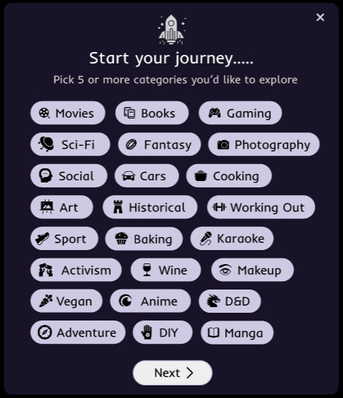Step 4: Review the terms and conditions, privacy policy, and click "Create Account" to complete the process.

Step 5: A few categories of interest will show up. Choose the ones that apply to you – you are allowed to choose as many as you desire.

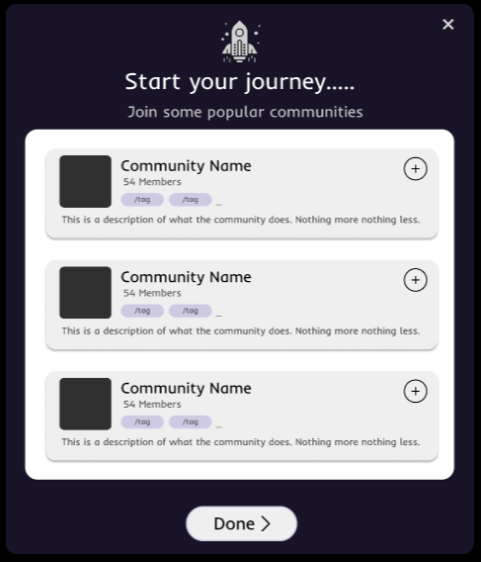

Step 6: A few recommended communities show up. Click on the “+” button on the communities you would like to join. When you are satisfied, you must click “Done”.

2.2 Logging In

To log in to your Encompass account, follow these steps:

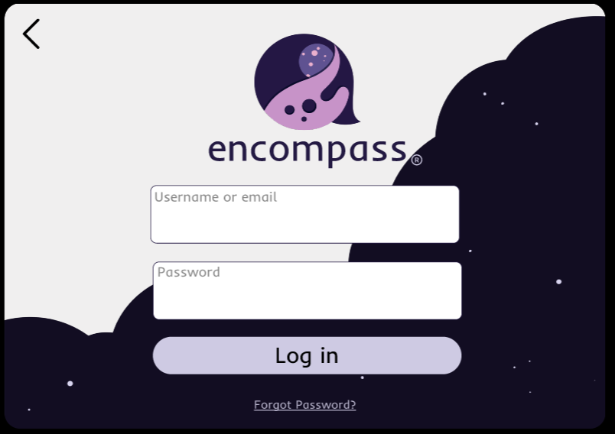Sep 1: On the Encompass homepage, click on "Log In."

Step 2: Enter your registered email address and password.

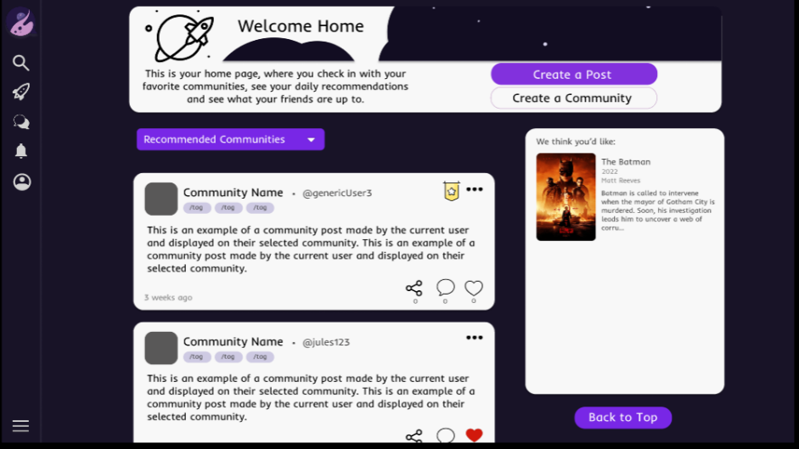

Step 3: Click "Log In" to access your Encompass account dashboard.

1. **Profile Management**

3.1 Editing Your Profile

Your Encompass profile allows you to showcase your interests and personality. To edit your profile, follow these steps:

[Screenshot: Home Page]

Step 1: Navigate to your profile page by clicking on your profile picture or username.

[Screenshot: Profile Page]

Step 2: Click on the "Edit Profile" button.

[Screenshot: Updating Info]

Step 3: Update your profile picture, bio, and any other desired information.

[Screenshot: Success change]

Step 4: Click on the "Save" button to save your changes.

3.2 Privacy Settings

Encompass provides privacy settings to give you control over the visibility of your profile and posts. To manage your privacy settings, follow these steps:

[Screenshot: Side Bar]

Step 1: Navigate to your setting by clicking on the “More” button and then on “Settings”.

[Screenshot: Setting Page]

Step 2: Click on the "Privacy Settings" option.

[Screenshot: Privacy Settings]

Step 3: Adjust the desired privacy settings for your profile and posts.

[Screenshot: Successful Changes]

Step 4: Click on the "Save" button to save your changes.

1. **Communities**

4.1 Browsing Communities

Encompass offers a wide range of communities based on different interests. To browse communities, follow these steps:

[Screenshot: Navigation Bar]

Step 1: Click on the "Search" tab in the navigation menu.

[Screenshot: Navigation Bar]

Step 2: Use the search bar to find specific communities. Note that recommended communities already appear on your feed page.

[Screenshot: Community Profile]

Step 3: Click on a community to view its details and posts.

4.2 Joining a community

To join a community on Encompass, follow these steps:

[Screenshot: Navigation Bar]

Step 1: Go to the community page by browsing or searching for the desired community.

[Screenshot: Community Profile Page]

Step 2: Click on the "Join" button.

[Screenshot: Overlay screenshot]

Step 3: Confirm your decision to join the community. Note that private and restricted communities will have to approve you request to join and public ones will allow you to automatically join.

1. **Sharing Content**

5.1 Posting Content

To post content within a community, follow these steps:

[Screenshot: Community page]

Step 1: Go to the community page where you want to share your post.

[Screenshot: Circled “create pots”]

Step 2: Click on the "Create Post" button.

[Screenshot: Create post overlay]

Step 3: Compose your post by adding text, images, or other relevant media.

[Screenshot: confirm post message]

Step 4: Click on the "Post" button to share your content with the community.

5.2 Commenting and Liking Posts

Engage with posts by commenting and liking them. To comment on a post, follow these steps:

[Screenshot: feed with post circled]

Step 1: Go to the post you want to comment on.

[Screenshot: circled comment box]

Step 2: Enter your comment in the provided comment box.

[Screenshot: show comment on post]

Step 3: Click on the "Post" button to submit your comment.

[Screenshot: like button circled]

To like a post, simply click on the "Like" button below the post.

5.3 Sharing Posts

To share a post with others, follow these steps:

[Screenshot: feed page with post circled]

Step 1: Go to the post you want to share.

[Screenshot: share button circled]

Step 2: Click on the "Share" button below the post.

[Screenshot: share link overlay]

Step 3: A link to the post will appear, copy it on your clipboard and paste it to share.

1. **Personalising Your Feed**

6.1 Selecting Interests

To select your interests and customize your feed, follow these steps:

[Screenshot: setting circled]

Step 1: Access the setting via the side bar.

[Screenshot: “Interests” button circled]

Step 2: Click on the "Interests" option.

[Screenshot: Suggested interests overlay]

Step 3: Browse through the available interest categories.

[Screenshot: successfully added interest]

Step 4: Click on the "+" button next to the interests you want to follow.

6.2 Customizing Feed Preferences

Encompass allows you to customize your feed preferences to control the type of content you see. To customize your feed preferences, follow these steps:

[Screenshot: feed page]

Step 1: Go to your feed page.

[Screenshot: feed page with Filter circled]

Step 2: Click on the "Filter" option.

[Screenshot: filter overlay screenshot]

Step 3: Adjust the desired settings, such as post sorting, content types, or community preferences.

[Screenshot: Successfully filtered message]

Step 4: Click on the "Save" button to apply your changes.

1. **Notifications and Messaging**

7.1 Managing Notifications

Encompass provides notifications to keep you updated on community activity, new posts, comments, and mentions. To manage your notifications, follow these steps:

[Screenshot: Notification button circled]

Step 1: Click on the notification bell icon in the left navigation bar.

[Screenshot: notification overlay]

Step 2: Review your notifications and click on a notification to view its details.

[Screenshot: notification settings overlay]

Step 3: To adjust notification settings, click on the "Settings" option.

7.2 Direct Messaging

Encompass allows you to engage in direct messaging with other users. To send a direct message, follow these steps:

[Screenshot: nav bar with message icon circled]

Step 1: Go to the message button on the nav bar.

[Screenshot: messages page]

Step 2: Click on the person you want to message.

[Screenshot: message overlay]

Step 3: Compose your message in the provided message box.

[Screenshot: messages history with ‘send’ button circled]

Step 4: Click on the "Send" button to send your message.

1. **Troubleshooting**

8.1 Frequently Asked Questions

Q: How do I reset my password?

A: To reset your password, follow these steps:

* Go to the Encompass login page.
* Click on the "Forgot Password" option.
* Follow the instructions provided to reset your password.

Q: How do I report inappropriate content or user behavior?

A: To report inappropriate content or user behavior, follow these steps:

* Go to the post or user profile you want to report.
* Click on the "Report" option.
* Provide details about the issue and submit the report.

Q: How can I delete my Encompass account?

A: If you wish to delete your Encompass account, please follow these steps:

* Log in to your Encompass account.
* Go to your profile page.
* Click on the "Account Settings" option.
* Look for the "Delete Account" section.
* Follow the provided instructions to permanently delete your account.

Q: Can I change my username on Encompass?

A: Yes, you can change your username on Encompass. Follow these steps to update your username:

* Log in to your Encompass account.
* Go to your profile page.
* Click on the "Edit Profile" button.
* Locate the "Username" field.
* Enter your desired username.
* Click on the "Save" button to update your username.

8.2 Contact Support

If you encounter any issues or have further questions, please contact our support team for assistance. You can reach us through the following channels:

Email: <perfectstrangers.tuks@gmail.com>

GitHub: [Encompass Project](https://github.com/COS301-SE-2023/Encompass)

1. **Appendix**

9.1 Terms of Service

Please refer to the Encompass Terms of Service for information regarding the terms and conditions governing the use of the Encompass application. They can be found here: [insert link]

9.2 Privacy Policy

Please review the Encompass Privacy Policy to understand how your personal information is collected, used, and protected within the Encompass application They can be found here: [insert link]

